Draft Roadmap for risk assessment
Prepared by the Ad Hoc Technical Expert Group on
Risk Assessment and Risk Management
Version of 7 March 2010

This “roadmap” provides an overview of the process of conducting a risk assessment on a living modified organism (LMO) in accordance with Annex III to the Cartagena Protocol on Biosafety (hereinafter “the Protocol”) and all other relevant articles. Annex III constitutes the basis of the Roadmap. Accordingly, this Roadmap is a guidance document and does not replace Annex III. The Roadmap is aimed at enhancing the technical and scientific process of how to apply the steps within the process of risk assessment.
The purpose of this Roadmap is to provide a) further guidance on using Annex III with additional background material, b) a rationale for five key steps in the risk assessment, c) additional points to consider for each of the five steps, and e) direct access to useful references. It may be useful as a reference for risk assessors when conducting new risk assessments or reviewing existing ones as well as in capacity building activities.
The Roadmap applies to all types of LMOs and their applications within the scope and objectives of the Protocol and according to Annex III as well as all other relevant article of the protocol. However, it has been developed with a special focus on Living Modified crop plants and Living Modified micro-organisms for environmental use because these are the types of LMOs that have been used most extensively in environmental releases and for which there is the most experience with risk assessments. It is intended to be a “living document” that will be modified and improved on over time as and when mandated by the Conference of the Parties serving as the meeting of the Parties to the Protocol (COP-MOP) and in the light of new experience, information and developments in the field of applications of LMOs, e.g. when the same or other types of LMOs have been evaluated more extensively in environmental risk assessments.

INTRODUCTION
General introduction
Background
In accordance with the precautionary approach, the objective of the Protocol is to contribute to ensuring an adequate level of protection in the field of the safe transfer, handling and use of LMOs resulting from modern biotechnology that may have adverse effects on the conservation and sustainable use of biological diversity, taking also into account risks to human health, specifically focusing on transboundary movements.
For this purpose, Parties shall ensure that risk assessments are carried out when making informed decisions regarding LMOs.
The objective of risk assessment is to identify and evaluate the potential adverse effects of LMOs on the conservation and sustainable use of biological diversity in the likely potential receiving environment, taking also into account risks to human health.
According to the general principles of Annex III of the Protocol, risk assessments shall be based, at a minimum, on information provided in accordance with Article 8 and other available scientific evidence in order to identify and evaluate the possible adverse effects of LMOs on the conservation and sustainable use of biological diversity, taking also into account risks to human health.
According to the general principles of Annex III, ‘risk assessment should be carried out in a scientifically sound and transparent manner, and can take into account expert advice of, and guidelines developed by, relevant international organizations. Lack of scientific knowledge or scientific consensus should not necessarily be interpreted as indicating a particular level of risk, an absence of risk, or an acceptable risk.’ Annex III further states that ‘Risk assessment should be carried out on a case-by-case basis. The required information may vary in nature and level of detail from case to case, depending on the LMO concerned, its intended use and the likely potential receiving environment.’
The risk assessment process
Risk assessment is a structured process. Paragraph 8 of Annex III provides a description of the key steps of the risk assessment process to identify, evaluate and manage potential risks. Paragraph 9 describes, depending on the case, points to consider in this process. The steps in paragraph 8 of Annex III describe an integrated process whereby the results of one step may be relevant to other steps. Also, risk assessment is often conducted in an iterative manner, where certain steps may be repeated or reexamined to increase the confidence in the conclusions of the risk assessment. Once a risk assessment has been concluded and new information arises that could change its conclusions, the risk assessment may need to be re-examined accordingly. Similarly, the issues mentioned in the ‘Overarching issues’ section below can be re-evaluated at the end of the risk assessment process to determine whether the objectives and criteria that were set out at the beginning of the risk assessment have been met.
According to the Protocol, ‘Risks associated with living modified organisms should be considered in the context of the risks posed by the non-modified recipients or parental organisms in the likely potential receiving environment.’ Further, experience withan LMO with the same, or, as appropriate, similar, genotypic and phenotypic characteristics may also be taken into consideration in the risk assessment. For instance, the comparison with the isogenic non-modified recipient is used in Step 1 of the risk assessment (see below) where the novel genotypic and phenotypic characteristics associated with the LMO are identified. But in Step 3, when evaluating the consequences of adverse effects should they be realized, broader experience may be taken into account, as a baseline, as is mentioned in Step 3 (a). Results from experimental field trials or other environmental information and experience with the same LMO may be taken into account as information elements in a new risk assessment for that LMO. In this case, as in all cases where information is derived from other sources (including baseline data), it is important to check the validity of the information for the risk assessment. For instance, it should be taken into account that the behaviour of a transgene in an LMO may depend to a large extent on the genetic and biological background of the recipient as well as on the ecological characteristics of the environment that the LMO is introduced into.
The concluding recommendations derived from the risk assessment in Step 5 are but one of the considerations that are required to be taken into account in the decision-making process regarding the approval of an LMO. In other parts of the decision-making process, other Articles of the Protocol or other relevant issues may also be taken into account and are addressed in the last paragraph of this Roadmap: ‘Issues related to risk assessment and/or decision-making on LMOs’.
A flowchart summarizing the risk assessment process is annexed hereto.
Overarching issues in the design/planning phase of the risk assessment process
There are some overarching issues to consider in the design/planning phase of the risk assessment process to ensure the quality and relevance of the information used. These entail, among others:
- Setting criteria for relevancy in the context of a risk assessment – e.g. data may be considered relevant if it can affect the outcome of the risk assessment.
- Establishment of scientifically robust standards for the inclusion of scientific information.
  - Data should be of an acceptable scientific quality. Data quality should be consistent with the accepted standard practices of scientific evidence-gathering and may include independent review of the methods and designs of studies. Data may be derived from a variety of sources, e.g. new experimental data as well as data from relevant peer reviewed scientific literature.
  - The principles of transparency, verifiability and reproducibility (e.g. reporting of methods and data in sufficient detail), including accessibility (e.g. availability of further relevant and required data or information or, if requested and as appropriate, of sample material, are of the most importance to ensure and verify that the risk assessment is carried out in a scientifically sound and transparent manner.

- “Where there is uncertainty regarding the level of risk, it may be addressed by requesting further information on the specific issues of concern or by implementing appropriate risk management strategies and/or monitoring the living modified organism in the receiving environment.”
, there is no universally accepted approach for addressing uncertainty in the risk assessment of LMOs.
Uncertainty is inherent in the concept of risk. In communicating the results of risk assessment and risk management it is therefore important to consider and analyze the various forms of uncertainty that may exist at each step of the risk assessment (and cumulatively at the last step). Current literature is replete with discussions on uncertainty analysis in risk assessment and in decision-making. (See references relevant to “Identification of the types and sources of uncertainty”).
In risk assessment uncertainty can arise at each of the various steps of the process. Types of uncertainty can differ, for instance, at: 1) the level at which uncertainty is generated, - e.g. statistical uncertainties, uncertainties with respect to the relevance of risk scenarios, recognized lack of knowledge, etc.; 2) the source of uncertainty, – e.g. what is the context of the risk assessment, which data are used as inputs, study/model design, choice of parameters, which conclusions are drawn from results, etc.; and 3) the nature of uncertainty,- e.g. due to naturally occurring variations or due to the way that the information is obtained in scientific experiments. Each of these types of uncertainty can be analyzed to characterize the specific uncertainties present in the risk assessment.
Where these considerations result in uncertainty regarding the level of risk, this may be addressed by requesting further information on the specific issues of concern. However, it should be kept in mind that uncertainty cannot always be reduced by providing additional information. For example, new uncertainties may arise as a result of the provision of additional information. Uncertainties may also be addressed in decision-making by requiring the implementation of appropriate risk management strategies or of targeted monitoring of the LMO in the receiving environment.
Uncertainty, due to, for instance, lack of scientific data, ambiguity or ignorance, may be addressed by applying the Precautionary Approach, taking also into account that a ‘lack of scientific knowledge or scientific consensus should not necessarily be interpreted as indicating a particular level of risk, an absence of risk, or an acceptable risk’. (See references relevant to “Precautionary approach”).
Context and scoping of the risk assessment
In setting the context and scope for a risk assessment, a number of aspects should be taken into consideration, as appropriate, that are specific to the Party involved and to the specific case of risk assessment. These aspects include, among others:
- (i) Existing policies and strategies based on, for instance, regulations and the international obligations of the Party involved; (ii) Guidelines or regulatory frameworks that the Party has adopted; and (iii) protection goals, end-points and management strategies .Setting the context and scope for a risk assessment that are consistent with these policies , strategies and protection goals may involve a process that includes risk assessors, decision-makers and various stakeholders prior to conducting the actual risk assessment ;
- (i) Framing the risk assessment process; (ii) Taking into account the expected (potential) conditions of handling and use of the LMO; (iii) Taking into account customary practices and habits that could affect the protection goals or end-points; identification of relevant questions to be asked for that purpose;
- Identification of methodological and analytical requirements, including any reviewing mechanism, that must be complied with to achieve the objective of the risk assessment as laid down, for instance, in guidelines published or adopted by the Party that is responsible for conducting the risk assessment (i.e. typically the Party of import according to the Protocol).
- The nature and level of detail of the information required may depend on the intended use of the LMO, e.g. in confined field releases* or an unconfined environmental release, such as commercial scale planting, and the likely potential receiving environment;
- Experience and history of use of the non-modified recipient, taking also into account its ecological function.; and
- Establishing criteria for describing the level of the (potential) environmental adverse effects of LMOs, as well as criteria for the terms that are used to describe the levels of likelihood (Step 2), the magnitude of consequences (Step 3) and risks (Step 4) and the manageability of risks (Step 5) (see risk assessment steps below).
(See references relevant to “Context and scoping”).
The risk assessment
To fulfill its objective under Annex III, as well as other relevant Articles of the Protocol, risk assessment is performed in five steps, as appropriate. These five steps are indicated in Paragraph 8 (a)-(e) of Annex III and also detailed below. Their titles have been taken directly from the paragraphs 8 (a)-(e) of Annex III.
For each step a rationale and points to consider are provided. Some points to consider are taken from paragraph 9 of Annex III, whereas others have been added based on generally accepted methodology of LMO risk assessment and risk management. The relevance of each point to consider will depend on the case being analyzed.
(See references relevant to “Risk Assessment in general”).
Step 1: “An identification of any novel genotypic and phenotypic characteristics associated with the living modified organism that may have adverse effects on biological diversity in the likely potential receiving environment, taking also into account risks to human health.”
Rationale:
The purpose of this step is to identify biological changes resulting from the genetic modification that could change the interaction of the LMO with its environment in a way that could cause adverse effects on the conservation and sustainable use of biological diversity, also taking into account risks to human health. It should be understood that the resulting change may also involve a deletion of genetic material.
This step is similar to the ‘hazard identification step’ in other risk assessment guidance. The comparison of the LMO with the non-modified recipient or, as appropriate, with a non-modified organism of the same species, serves this purpose.
In this step, plausible hazard scenarios are identified in which novel characteristics of the LMO could give rise to adverse effects in an interaction with the likely potential receiving environment. The novel characteristics of the LMO to be considered can be genotypic and phenotypic, intended and unintended. The points to consider below provide information elements on which hazard identification can be built.
The type and level of detail of the information required in this step may vary from case to case depending on the nature of the modification of the LMO and on the scale of the intended use of the LMO. For confined releases, for instance, less information may be available while the resulting uncertainty may be risk management.
Points to consider regarding the characterization of the LMO:
- Characteristics of the non-modified recipient (e.g. (i) its biological characteristics, with particular attention to characteristics that, if changed, or interacting with genes that were inserted into the LMO, could change the interaction of the non-modified recipient with the environment in a way that may cause adverse effects; (ii) its taxonomic relationships, (iii) its origin, centers of origin and centers of genetic diversity); (See references relevant to “Step 1 – Point to consider (a)”).
- Relevant characteristics of the genes that have been inserted into the LMO (e.g. functions of the gene product in the donor organism with particular attention to characteristics that, when transferred to the recipient, could cause adverse effects); (See references relevant to “Step 1 – Point to consider (b)”).
- Molecular characteristics of the LMO related to the modification (e.g. characteristics of the insert(s) including (i) gene products, (ii) expression level, (iii) function, (iv) insertion site in the genome of the recipient, (v) stability or integrity, (vi) transformation method, (vii) characteristics of the vector if and, as far as it is present in the LMO, including its identity, source or origin and host range) with particular attention paid to characteristics that are related to potential adverse effects. The availability and relevance of this information may vary according to the type of application, such as for introduction into the environment for commercial or for field trial purposes. Characteristics related to adverse effects may also result from altered expression levels of endogenous genes due to effects of a transgene (e.g. due to insertional disruption of a gene, chimeric genes that have arisen by linking endogenous genes to inserted genes or to regulatory effects). Adverse effects may also result from combinatorial effects (the effects of combinations of genes) such as cumulative or synergistic effects of the transgene product with endogenous genes or products of other transgenes present in the LMO; (See references relevant to “Step 1 – Point to consider (c)”).
- Identification of genotypic and phenotypic, biological changes in the LMO, either intended or, unintended, in comparison with the non-modified recipient, considering those changes that could cause adverse effects. These may include changes on the transcriptional and translational level and may be due to the insert itself or genomic changes incurred due to the transformation process.
Point to consider regarding the receiving environment:
- Characteristics of the likely potential receiving environment, in particular its attributes that are relevant to potential interactions of the LMO that could lead to adverse effects (see also paragraph (f) below);
Points to consider regarding the potential adverse effects resulting from the interaction between the LMO and the receiving environment:
- Characteristics of the LMO in relation to the receiving environment (e.g. information on phenotypic traits that are relevant for its survival in or its interaction with the likely receiving environment – see also paragraph (e) above);
- Considerations for unmanaged and managed ecosystems (such as agricultural, forest and aquaculture systems) which are relevant for the likely potential receiving environment. These include the potential for dispersal of the LMO through, for instance, seed dispersal or outcrossing within or between species, or through escape in habitats where the LMO may persist or proliferate;
- Unintentional outcrossing and flow of transgenes from an LMO to other sexually compatible species may occur. The consequences may include: introgression of the transgene(s) into the population of the sexually compatible species. In such cases, considerations should include: (i) the biology of the sexually compatible species, (ii) effects of the transgene(s), if introgressed, (iii) the potential environment where the sexually compatible species may be located in this genetic background and (iv) the possible adverse effects that may occur due to the presence of the transgenes in the sexually compatible species; and
- Adverse effects as a consequence of horizontal gene transfer (HGT) from the LMO. Concerning HGT to micro-organisms (including viruses), particular attention needs to be given to sequences present in the LMO that have been derived from micro-organisms as well as in cases where the LMO itself is a micro-organism.
Step 2: “An evaluation of the likelihood of adverse effects being realized, taking into account the level and kind of exposure of the likely potential receiving environment to the living modified organism.”
Rationale:
The potential adverse effects identified in Step 1 may result in risks depending on the likelihood and the consequence of the effects. In order to determine the level of the overall risk (in Step 4), the likelihood of each adverse effect being realized has to be evaluated beforehand. One aspect to be considered in evaluating the likelihood of the adverse effects is whether the receiving environment will be exposed to the LMO in such a way that the identified adverse effects may actually occur, e.g. taking into consideration the intended use of the LMO, and the expression level, dose and environmental fate of transgene products. Other aspects to be considered here are (i) the potential of the LMO or its derivatives (i.e. sexually compatible organisms in which transgenes have introgressed) to spread and establish beyond the receiving environment, and whether that could affect or displace the same or other species; and (ii) the possibility of occurrence of adverse (e.g. toxic) effects on organisms (or on organisms other than the ‘target organism’ for some types of LMOs). The levels of likelihood may be expressed, for example, by the terms ‘highly likely’, ‘likely’, ‘unlikely’, ‘highly unlikely’. It is recommended that these terms and their uses be described in, for instance, risk assessment guidelines that has been published or adopted by the Party.
Points to consider:
- Information relating to the type and intended use, including proposed control measures if applicable, of the LMO as well as the scale of release;
- The relevant characteristics of the likely potential receiving environment that may experience or may be a factor in the occurrence of the potential adverse effects (see also Step 1, (e), (f) and (g));
- Levels of expression in the LMO and persistence and accumulation in the environment (e.g. in the food chain) of potentially harmful substances newly produced by the LMO such as insecticidal proteins;
- Available information on the receiving environment* (such as detailed geographic and biogeographic information, including, for example, coordinates, information on the sexually compatible species and whether they are co-localized with the LMO and whether flowering occurs at the same time); and
- Expected exposure to the environment where the LMO is released and means by which incidental exposure could occur at that location or elsewhere (e.g. gene flow or incidental exposure due to losses during transport and handling).
Step 3: “An evaluation of the consequences should these adverse effects be realized.”
Rationale:
This step describes an evaluation of the severity of the consequences in the likely potential receiving environment, taking into account, among others, results of tests done under different conditions such as laboratory experiments or confined field releases. The evaluation should be considered in the context of the adverse effects caused by the non-modified recipient or by a non-modified organism of the same species. It should also be considered in the context of the adverse effects that occur in the environment due to comparable existing practices such as agronomic practices for pest or weed management. The evaluation of the consequence of adverse effects may be expressed as, for instance, ‘major’, ‘intermediate’, ‘minor’ or ‘marginal’. It is recommended that these terms and their uses be described in, for instance, risk assessment guidelines that has been published or adopted by the Party. (See references relevant to “Step 3”).
Points to consider:
- Relevant experience with the consequences of existing practices with the non-modified recipient or with a non-modified organism of the same species in the likely potential receiving environment, as applicable, in order to establish baselines to evaluate, for example, the consequences of (i) agricultural practices, such as the level of inter- and intra-species gene flow, dissemination of the recipient, abundance of volunteer plants in crop rotation; or (ii) pest management, including effects on non-target organisms in pesticide applications while following accepted agronomic practices; (See references relevant to “Step 3 – Point to consider (a)”).
- Direct and indirect, immediate and delayed effects as well as combinatorial effects (see Step 1, point to consider (c)), such as dominant/recessive effects, effects of gene silencing, cumulative or synergistic effects, leading to adverse consequences. (See references relevant to “Step 3 – Point to consider (b)”).
Step 4: “An estimation of the overall risk posed by the living modified organism based on the evaluation of the likelihood and consequences of the identified adverse effects being realized.”
Rationale:
The purpose of this step is to determine and characterize the cumulative level of risk posed by the LMO on the biological diversity, taking into account human health, based on a combined analysis of the potential adverse effects identified in Step 1) their likelihood (Step 2) and consequences (Step 3), and also taking into consideration any relevant uncertainty that emerged in the preceding steps.
It should then be determined whether the identified risks meet the criteria for acceptability relative to assessment endpoints as established in relevant statutes or regulations. Where there is uncertainty regarding the level of risk, it may be addressed by requesting further information on the specific issues of concern or by implementing appropriate risk management strategies and/or monitoring the LMO in the receiving environment (see also Step 5). The estimation of the ‘overall risk’ in this step does not take into account the potential benefits of the LMO under the conditions of use. Qualification of the risk estimation in determining the level of the overall risk may be expressed as, for instance, ‘negligible’, ‘low’, ‘medium’, ‘high’ or ‘indeterminate due to uncertainty or lack of knowledge’. It is recommended that these terms and their uses be described in, for instance, risk assessment guidelines published or adopted by the Party. (See references relevant to “Step 4”).
Points to consider:
- The assessments of likelihood (Step 2);
- The evaluation of the consequences (Step 3);
- Potential cumulative adverse effects due to the presence of multiple LMOs in the receiving environment and synergistic/combinatorial potential adverse effects due to the presence of multiple transgenes or DNA sequences in the LMO and traits that may interact.; and
- Analysis of uncertainty conducted to characterize and address uncertainties (including variability) inherent in scientific information used in the risk assessment.
Step 5: “A recommendation as to whether or not the risks are acceptable or manageable, including, where necessary, identification of strategies to manage these risks”
Rationale:
If the evaluation of the overall risk conducted in the previous step leads to the conclusion that the identified risks are not negligible, the question arises whether those risks are acceptable and whether risk management options can be identified that have the potential to remove the identified risks or reduce their levels. In the process of the formulation of risk management options, the effect of the proposed options on the identified risks should be explained. The risk assessment should then be reiterated by taking into account the implementation of the risk management options to estimate the new levels of likelihood, consequence and risk. In this way, Step 5 provides an interface for interaction between the process of risk assessment and the process of determining whether risk management measures are necessary and what strategies could be put in place to manage the risks associated with the LMO should it be introduced in the likely receiving environment. The determination of the necessary and adequate risk management strategies is not covered by this Roadmap.
The recommendation of acceptability of risk(s) should acknowledge the previously identified uncertainties. Some uncertainties may be addressed by monitoring (e.g. checking the validity of assumptions about the ecological effects of the LMO), requests for more information, or implementing the appropriate risk management options.
The recommendation(s) as to whether or not the risks are acceptable or manageable are submitted for consideration by the decision-makers. (See references relevant to “Step 5”).
Points to consider related to the acceptability of risks:
- The criteria for the establishment of acceptable/unacceptable levels of risk, including those set out in national legislation or guidelines, as well as the protection goals of the Party, as identified when setting the context and scope for a risk assessment;
- Relevant risks posed by the use of the non-modified recipient, and practices associated with its use in the potential receiving environment, providing a baseline for the comparison with the LMO.
Points to consider related to the RM strategies:
- Existing management practices, if applicable, that are in use for the non-modified recipient organism or for other organisms, including LMOs, that require comparable risk management and that might be appropriate for the LMO being assessed, e.g. isolation distances to reduce outcrossing potential of the LMO, modifications in herbicide or pesticide management, crop rotation, soil tillage, etc.;
- Methods to detect and identify the LMO and their specificity, sensitivity and reliability in the context of environmental monitoring (e.g. monitoring for short- and long-term, immediate and delayed effects; specific monitoring on the basis of scientific hypotheses and cause/effect relationship as well as general monitoring) including plans for appropriate contingency measures to be applied in case the results from monitoring call for them; (See references relevant to “Step 5 – Point to consider (d)”).
- Management options in the context of the intended use (e.g. mitigating the effect of an LMO producing insecticidal proteins by the use of refuge areas to minimize the development of resistance against these proteins).

Issues related to risk assesement and/or decision-making on Lmos

In conducting risk assessment as well as in the decision making procedure, a number of articles of the protocols are relevant and related to process. These include, interalia
- Article 14: Bilateral, regional and multilateral agreements and arrangements
- Article 17: Unintentional transboundary movement and emergency measures
- Article 22: Capacity building
- Article 23: Public awareness and participation
- Article 26: Socio-economic considerations
- Article 27: Liability and Redress
Some further issues that are frequently mentioned in relation to risk assessment and LMO decision-making, but that are not within the scope of Annex III of the Protocol, include the following:
- Ethical issues;
- Effects on human health in the context of food or feed safety,
- Coexistence.
- Consumers practices, patterns and habits.

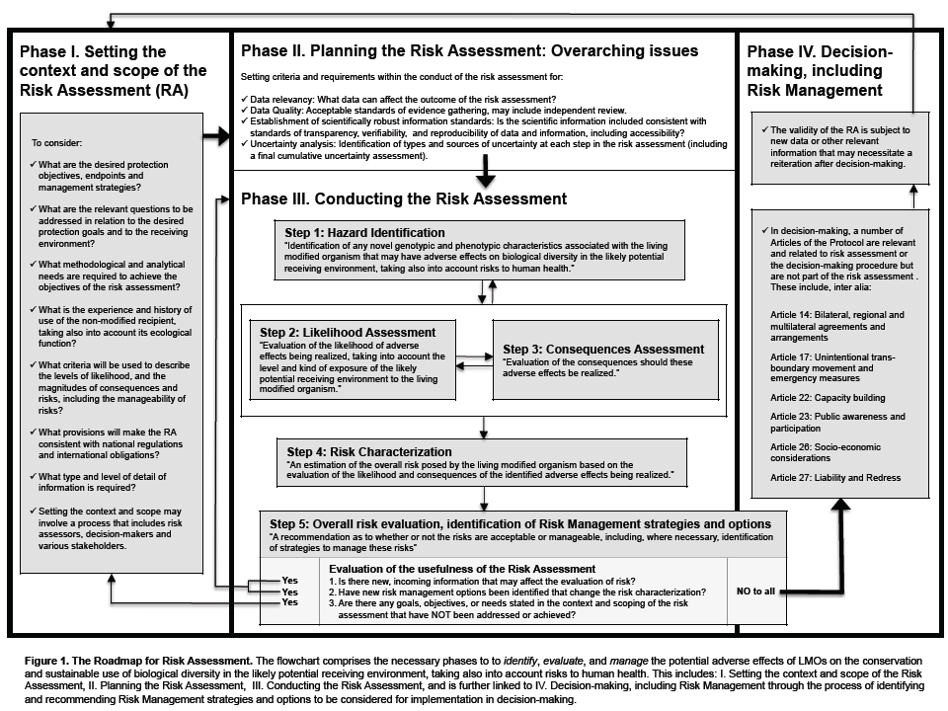
ANNEX – FLOWCHART FOR RISK ASSESSMENT

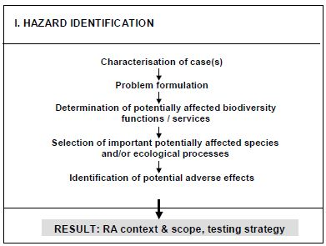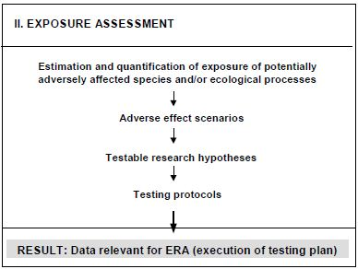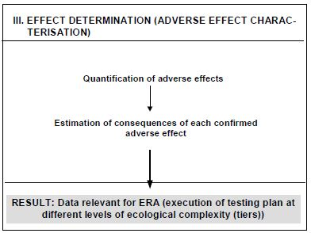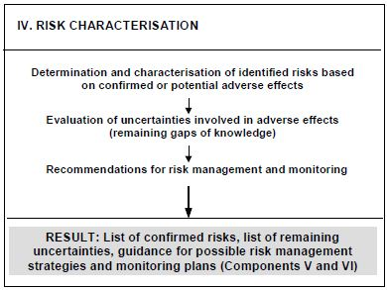
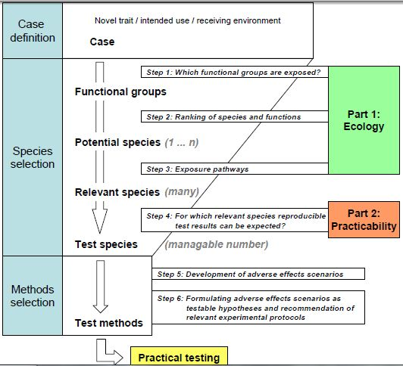

http://www.cbd.int/biosafety/articles.shtml?a=cpb-43
http://www.cbd.int/biosafety/articles.shtml?a=cpb-01
Annex III, 1
Article 15, 1
Annex III, 3, 4 and 6
Annex III, 5
Annex III, paragraph 8(f)
As stated in Article 1 of the Protocol
Annex III, paragraph 4
Terms with an asterisk (*) do not apply to commercial releases, but may apply to confined or unconfined field trials.
The term ‘ecological function’ (or: ‘ecological services)’ provided by an organism refers to the role of the organism in ecological processes. Which ecological functions or services are taken into account here will be dependent on the protection goals set for the risk assessment. For example, organisms may be part of the decomposer network playing an important role in nutrient cycling in soils or be important as a pollen source for pollinators and pollen feeders.
The bold printed headings of each step are direct quotes from Annex III of the Protocol.
Examples of relevant attributes of the receiving environment include, among others: (i) type (e.g. agroecosystem; horticultural or forest ecosystems, soil or aquatic ecosystems), (ii) structure (small, medium, large or mixed scale); (iii) previous use/history (intensive or extensive use for agronomic purposes, natural ecosystem, or no use of the ecosystem); (iv) the ecosystem type(s) or geographical zone(s) in which the release is intended, including climatic and geographic conditions and the properties of soil, water and/or sediment; (v) specific characteristics of the prevailing faunal, floral and microbial communities including information on sexually compatible wild or cultivated species; and (vi) biodiversity status, including the status as centre of origin and diversity of the recipient organism and the occurrence of rare, endangered, protected species and/or species of cultural value.
Consideration of risks versus (environmental) benefits may be performed during the process of decision making.

