Draft Roadmap for risk assessment
Prepared by the Ad Hoc Technical Expert Group on
Risk Assessment and Risk Management
Version of 7 March 2010

This “roadmap” provides an overview of the process of environmental risk assessment for living modified organisms (LMO) in accordance with Annex III to the Cartagena Protocol on Biosafety (hereinafter “the Protocol”). This Roadmap was developed in response to Decision BS IV/11, and Annex III is the basis of the Roadmap. Accordingly, this Roadmap is a guidance document and intended to elaborate on Annex III. The Roadmap is aimed at enhancing the technical and scientific process of how to apply the steps regarding risk assessment.
The purpose of this Roadmap is to provide further guidance on using Annex III with additional background material and links to useful references. In addition, the Roadmap contains a rationale for the five key steps in the risk assessment, and additional points to consider for each of the five.. It may be useful as a reference for risk assessors when conducting new risk assessments or reviewing existing ones as well as in capacity building activities.
The Roadmap applies to all types of LMOs and their intended uses within the scope of the Protocol according to Annex III. However, it has been developed based largely on LMO crop plants and micro-organisms for environmental use because of the extensive experience with risk assessments for these organisms to date. It is intended to be a “living document” that will be modified over time based on experience with other types of LMOs and when mandated by the Conference of the Parties serving as the meeting of the Parties to the Protocol (COP-MOP),.

INTRODUCTION
General introduction
Background

The objective of risk assessment is to identify and evaluate the potential adverse effects of LMOs on the conservation and sustainable use of biological diversity in the likely potential receiving environment, taking also into account risks to human health. An LMO may have environmental effects that can be assessed for their potential to be adverse on a case-by-case basis. What is considered adverse effects depends on protection goals and risk assessment end-points as chosen by the Party and set out in existing policies and strategies. The risk assessment provides scientific information to risk managers to make the determination of “likely adverse” or not.

’
The risk assessment process
Risk assessment is a structured process. Paragraph 8 of Annex III provides a description of the key steps of the risk assessment process to identify, evaluate and manage potential risks. Paragraph 9 describes, depending on the case, points to consider in this process. The steps in paragraph 8 of Annex III describe an integrated process whereby the results of one step may be relevant to other steps. Also, risk assessment may need to be conducted in an iterative manner, where certain steps may be reexamined based on new information to increase the confidence in the conclusions of the risk assessment. When new information arises that could change conclusions the conclusions of a risk assessment, the process may need to be re-examined accordingly..
.

A flowchart summarizing the risk assessment process is annexed hereto.
Overarching issues in the design/planning phase of the risk assessment process
There are some overarching issues to consider in the design/planning phase of the risk assessment process:

- Establishing early in the process the decision options (e.g., contained or uncontained release), a definition of harm in the context of the request and the amount of information needed to inform the decision-maker.
- Establishing acceptable standards for data quality, reconstructability and transparency.

- Recognition that uncertainty is an outcome of any scientific undertaking as has been noted in Annex III: “Where there is uncertainty regarding the level of risk, it may be addressed by requesting further information on the specific issues of concern or by implementing appropriate risk management strategies and/or monitoring the living modified organism in the receiving environment.”

Context and scoping of the risk assessment
In setting the context and scope for a risk assessment, a number of aspects might be taken into consideration,:
- Existing policies, regulations and the international obligations of the Party involved; e.g.,
- Guidelines that the Party has adopted, and describing required end-points and

- methodological and analytical requirements, including any reviewing mechanism, that must be complied with to achieve the objective of the risk assessment as laid down in guidelines published or adopted by the Party that is responsible for conducting the risk assessment (i.e. typically the Party of import according to the Protocol).

- Experience and history of use of the non-modified recipient, taking also into account its ecological function.; and

(See references relevant to “Context and scoping”).
The risk assessment
To fulfill its objective under Annex III, as well as other relevant Articles of the Protocol, risk assessment is performed in five steps, as appropriate. These five steps are indicated in Paragraph 8 (a)-(e) of Annex III and also detailed below. Their titles have been taken directly from the paragraphs 8 (a)-(e) of Annex III.
For each step a rationale and points to consider are provided. Some points to consider are taken from paragraph 9 of Annex III, whereas others have been added based on generally accepted methodology of LMO risk assessment and risk management. The relevance of each point to consider will depend on the case being analyzed.
(See references relevant to “Risk Assessment in general”).
Step 1: “An identification of any novel genotypic and phenotypic characteristics associated with the living modified organism that may have adverse effects on biological diversity in the likely potential receiving environment, taking also into account risks to human health.”
Rationale:
The purpose of this step is to identify biological changes resulting from the genetic modification compared to the non-modified organisim and identify what, if any, changes could cause adverse effects on the conservation and sustainable use of biological diversity, also taking into account risks to human health..
This step is similar to the ‘hazard identification step’ in other risk assessment guidance. The comparison of the LMO with the non-modified recipient or, as appropriate, with a non-modified organism of the same species, serves this purpose.
In this step, plausible hazard scenarios are identified in which novel characteristics of the LMO could give rise to adverse effects in an interaction with the likely potential receiving environment. The novel characteristics of the LMO to be considered can be genotypic and phenotypic, intended and unintended.
The type and level of detail of the information required in this step may vary from case to case depending on the nature of the modification of the LMO and on the scale of the intended use of the LMO. For confined releases, typically a risk assessor needs information to ensure that the release will be appropriately confined (OECD 1992).
Points to consider regarding the characterization of the LMO:
- Characteristics of the non-modified recipient (e.g. (i) its biological characteristics, with particular attention to characteristics that, if changed, may cause adverse effects; (ii) its taxonomic relationships, (iii) its origin, centers of origin and centers of genetic diversity); (See references relevant to “Step 1 – Point to consider (a)”).
- Relevant characteristics of the genes that have been inserted into the LMO (e.g. functions of the gene product in the donor organism with particular attention to characteristics that could cause adverse effects); (See references relevant to “Step 1 – Point to consider (b)”).
- Molecular characteristics of the LMO related to the modification (e.g. characteristics of the insert(s) including (i) gene products, (ii) expression level, (iii) function, (, (v) stability (vi) transformation method, (vii) characteristics of the vector if and, as far as it is present in the LMO, including its identity, source or origin and host range) with particular attention paid to characteristics that are related to potential adverse effects.; (See references relevant to “Step 1 – Point to consider (c)”).
- Identification of genotypic and phenotypic changes in the LMO detected in comparison with the non-modified recipient, considering those changes that could cause adverse effects.
Point to consider regarding the receiving environment:
- Characteristics of the likely potential receiving environment, in particular its attributes that are relevant to potential interactions of the LMO that could lead to adverse effects (see also paragraph (f) below);
Points to consider regarding the potential adverse effects resulting from the interaction between the LMO and the receiving environment:
- Characteristics of the LMO in relation to the receiving environment (e.g. information on phenotypic traits that are relevant to its potential to become invasive in the likely receiving environment – see also paragraph (e) above);
- Considerations for unmanaged and managed ecosystems (such as agricultural, forest and aquaculture systems) which are relevant for the likely potential receiving environment. These include the potential for dispersal of the LMO through, for instance, seed dispersal or outcrossing within or between species;
- The consequences of outcrossing and flow of transgenes from an LMO to other sexually compatible species. The consequences are considered based on their potential for the recipient plant or community to cause adverse environmental impacts. ; and
- Adverse effects as a consequence of horizontal gene transfer (HGT) from the LMO. Concerning HGT to micro-organisms (including viruses), particular attention needs to be given to sequences present in the LMO that have been derived from micro-organisms as well as in cases where the LMO itself is a micro-organism.
Step 2: “An evaluation of the likelihood of adverse effects being realized, taking into account the level and kind of exposure of the likely potential receiving environment to the living modified organism.”
Rationale:
The potential adverse effects identified in Step 1 may result in risks depending on the likelihood and the consequence of the effects. In order to characterize the overall risk (in Step 4), the potential for and routes of exposure to the likely receiving environment has to be evaluated beforehand. This is typically done by taking into consideration the intended use of the LMO, the presence of wild relatives and their potential to cross with the LMO in the environment, as well as the expression level, dose and environmental fate of transgene products.). The levels of likelihood may be expressed, for example, by the terms ‘highly likely’, ‘likely’, ‘unlikely’, ‘highly unlikely’. It is recommended that these terms and their uses be described in, for instance, risk assessment guidelines that has been published or adopted by the Party.
Points to consider:
- Information relating to the type and intended use, including proposed control measures if applicable, of the LMO as well as the scale of release;
- The relevant characteristics of the likely potential receiving environment that may experience or may be a factor in the occurrence of the potential adverse effects (see also Step 1, (e), (f) and (g));
- Levels of expression in the LMO and persistence and accumulation in the environment (e.g. in the food chain) of potentially harmful substances newly produced by the LMO such as insecticidal proteins;
- Available information on the receiving environment* (such as detailed geographic and biogeographic information, including, for example, coordinates, information on the sexually compatible species and whether they are co-localized with the LMO and whether flowering occurs at the same time); and
- Expected exposure to the environment where the LMO is released and means by which incidental exposure could occur at that location or elsewhere (e.g. gene flow or incidental exposure due to losses during transport and handling).
Step 3: “An evaluation of the consequences should these adverse effects be realized.”
Rationale:
This step describes an evaluation of the magnitude of the consequences in the likely potential receiving environment typically using a weight of evidence approach. As such, results from tests are associated with potential harms. For example, phenotypic data are used to assess potential invasiveness and unintended effects. Similarly, laboratory experiments are useful to assess the potential for harm to occur to non-target organisms.. The evaluation should be considered in the context of the adverse effects caused by the non-modified recipient or by a non-modified organism of the same species. The context of the adverse effects that occur in the environment due to changing cultural practices such as agronomic practices for pest or weed management may need to be considered. The evaluation of the consequence of adverse effects may be expressed as, for instance, ‘major’, ‘intermediate’, ‘minor’ or ‘marginal’. It is recommended that these terms and their uses be described in, for instance, risk assessment guidelines that has been published or adopted by the Party. (See references relevant to “Step 3”).
Points to consider:
- Results from field trials evaluating invasiveness and laboratory experiments examining dose-response relationships (e.g., EC 50s, LD 50s etc)
- Depending on regulatory policies, relevant experience with the consequences of existing practices with the non-modified recipient or with a non-modified organism of the same species in the likely potential receiving environment may need to be considered in order to establish baselines to evaluate, for example, the consequences of (i) agricultural practices, such as the level of inter- and intra-species gene flow, dissemination of the recipient, abundance of volunteer plants in crop rotation; or (ii) pest management, including effects on non-target organisms in pesticide applications while following accepted agronomic practices; (See references relevant to “Step 3 – Point to consider (a)”).
- . (See references relevant to “Step 3 – Point to consider (b)”).
Step 4: “An estimation of the overall risk posed by the living modified organism based on the evaluation of the likelihood and consequences of the identified adverse effects being realized.”
Rationale:
The purpose of this step is to determine and characterize the level of risk posed by the LMO based on analysis of the potential adverse effects identified in Step 1) their likelihood (Step 2) and consequences (Step 3), and also taking into consideration any relevant uncertainty that emerged in the preceding steps.
When clear risk assessment thresholds are available and appropriate to the local process, the result can be used to determine whether the identified risks meet the criteria for acceptability relative to assessment endpoints as established in relevant statutes or regulations. Where there is uncertainty regarding the level of risk, it may be addressed by requesting further information on the specific issues of concern or by implementing appropriate risk management strategies and/or monitoring the LMO in the receiving environment (see also Step 5). The estimation of the ‘overall risk’ in this step does not take into account the potential benefits of the LMO under the conditions of use. Some regulatory authorities may conduct a benefits or cost/benefit analysis. Description of the risk characterization may be expressed as, ‘negligible’, ‘low’, ‘medium’, ‘high’ with reasons stated for each. ’. (See references relevant to “Step 4”).
Points to consider:
- The assessments of likelihood (Step 2);
- The evaluation of the consequences (Step 3);
- Potential cumulative adverse effects due to the presence of multiple LMOs in the receiving environment.; and
- Consideration of uncertainty given within the assessment to characterize and address uncertainties (including variability).
Step 5: “A recommendation as to whether or not the risks are acceptable or manageable, including, where necessary, identification of strategies to manage these risks”
Rationale:
Recognizing that some authorities have prescriptive requirements for post-market monitoring, the information from Step 4 is often used to determine what, if any, risk management options are appropriate. In the process of the formulation of risk management options, the effect of the proposed options on the identified risks should be explained. The risk assessment should then be reiterated by taking into account the implementation of the risk management options to estimate the new levels of likelihood, consequence and risk. In this way, Step 5 provides an interface for interaction between the process of risk assessment and the process of determining whether risk management measures are necessary and what strategies could be put in place to manage the risks associated with the LMO should it be introduced in the likely receiving environment.

(See references relevant to “Step 5”).
Points to consider related to the acceptability of risks:
- The criteria for the establishment of acceptable/unacceptable levels of risk, including those set out in national legislation or guidelines, as well as the protection goals of the Party, as identified when setting the context and scope for a risk assessment;
- Relevant risks posed by the use of the non-modified recipient, and practices associated with its use in the potential receiving environment, providing a baseline for the comparison with the LMO.
Points to consider related to the RM strategies:
- Existing risk management practices, if applicable, that are in use for the non-modified recipient organism or for other organisms, including LMOs, that require comparable risk management and that might be appropriate for the LMO being assessed, e.g. isolation distances to reduce outcrossing potential of the LMO, modifications in herbicide or pesticide management, crop rotation, soil tillage, etc.;
- Methods to detect and identify the LMO and their specificity, sensitivity and reliability in the context of environmental monitoring (e.g. monitoring for short- and long-term, immediate and delayed effects; specific monitoring on the basis of scientific hypotheses and cause/effect relationship as well as general monitoring) including plans for appropriate contingency measures to be applied in case the results from monitoring call for them; (See references relevant to “Step 5 – Point to consider (d)”).
- Management options in the context of the intended use (e.g. mitigating the effect of an LMO producing insecticidal proteins by the use of refuge areas to minimize the development of resistance against these proteins).

Issues related to decision-making
The environmental risk assessment of an application of an LMO is part of a larger process of decision-making in which other issues may also be taken into account. A number of these issues, that are not part of the risk assessment process per se, are mentioned in the following Articles of the Protocol:
- Article 10 (this is relevant to the risk assessment process)
- Article 14: Bilateral, regional and multilateral agreements and arrangements

- Article 23: Public awareness and participation
- Article 26: Socio-economic considerations

Some further issues that are frequently mentioned in relation to LMO decision-making, but that are not within the scope of risk assessment according to Annex III of the Protocol, include the following:
- Ethical issues;
- Effects on human health in the context of food or feed safety, taking into account consumer practices, patterns and habits;
- Coexistence.

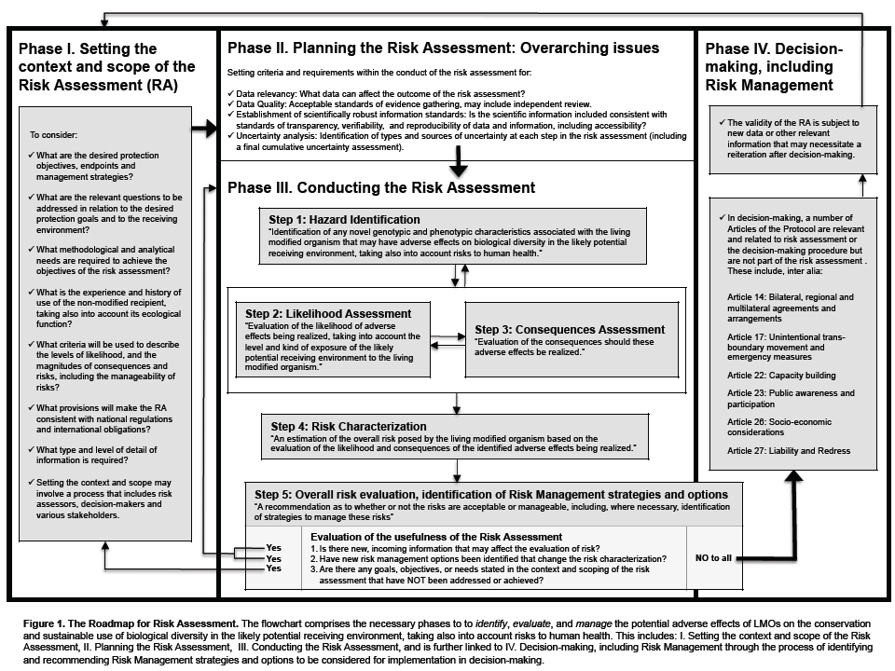
ANNEX – FLOWCHART FOR RISK ASSESSMENT

http://www.cbd.int/biosafety/articles.shtml?a=cpb-43
Annex III, 1
Annex III, paragraph 8(f)
The term ‘ecological function’ (or: ‘ecological services)’ provided by an organism refers to the role of the organism in ecological processes. Which ecological functions or services are taken into account here will be dependent on the protection goals set for the risk assessment. For example, organisms may be part of the decomposer network playing an important role in nutrient cycling in soils or be important as a pollen source for pollinators and pollen feeders.
The bold printed headings of each step are direct quotes from Annex III of the Protocol.
Examples of relevant attributes of the receiving environment include, among others: (i) type (e.g. agroecosystem; horticultural or forest ecosystems, soil or aquatic ecosystems), (ii) structure (small, medium, large or mixed scale); (iii) previous use/history (intensive or extensive use for agronomic purposes, natural ecosystem, or no use of the ecosystem); (iv) the ecosystem type(s) or geographical zone(s) in which the release is intended, including climatic and geographic conditions and the properties of soil, water and/or sediment; (v) specific characteristics of the prevailing faunal, floral and microbial communities including information on sexually compatible wild or cultivated species; and (vi) biodiversity status, including the status as centre of origin and diversity of the recipient organism and the occurrence of rare, endangered, protected species and/or species of cultural value.
Consideration of risks versus (environmental) benefits may be performed during the process of decision making.

