 |  | CBD
 |  |  |  | Distr.  GENERAL  28 February 2018  ENGLISH ONLY

Report on the Asia-Pacific Science-Policy Dialogue on the Detection and Identification of Living Modified Organisms

Introduction
- The Secretariat organized a webinar for the Asia-Pacific region to promote a science-policy dialogue on the detection and identification of living modified organisms (LMOs). The objective of the webinar was to facilitate an exchange of views among policymakers and scientists on how laboratory analyses of LMOs can best respond to specific national regulatory needs in an effective manner.
- The webinar was organized in line with requests made during the Asia-Pacific Workshop on the Detection and Identification of Living Modified Organisms, which was held in Kuala Lumpur from 20 to 24 March 2017, for the Secretariat to facilitate the exchange of views among policymakers and scientists to discuss the strengths and limitations of methods for the detection of LMOs in order to inform policymaking and implementation, including those policies that set requirements for the identification and quantification of LMOs by exporters.
Attendance
- A total of 45 participants from 11 Parties in the Asian region were nominated to take part in the webinar.
- The webinar was held on 26 January 2018. Of the nominated participants, 35 participants from the following 10 Parties attended the workshop: Bhutan; China; India; Iran (Islamic Republic of); Iraq; Malaysia; Philippines; Republic of Korea; Sri Lanka; and Viet Nam.

Presentations on the on how laboratory analyses of living modified organisms can best respond to specific national regulatory needs in an effective manner
- In opening the webinar, Ms. Dina Abdelhakim, from the Secretariat of the Convention on Biological Diversity, introduced the workshop objectives and its organization of work. She also introduced each of the resource persons to the webinar participants.
- Each of the resource persons gave an overview of the provisions in their country’s biosafety frameworks and the provisions outlined for the detection and identification of LMOs, as listed below:
  - Overview of the biosafety legislation and requirements for the detection and identification of LMOs in Malaysia. By: Mr. Letchu Rama;
  - Overview of the strengths and limitations of detection methods and how the available tools and techniques can be used to fulfil the needs of policymakers. By: Ms. Yuvaneswari Swaran;
  - Biosafety regulation and GMOs detection and identification in Thailand. By: Ms. Piyarat Thammakijjawat;
  - National Biosafety Framework in Bhutan. By: Mr. Jambay Dorji.
- Each presentation was followed by a brief question-and-answer period between the resource person and the participants.

Conclusions and recommendations
- Under this agenda item, Ms. Abdelhakim invited the workshop participants to put forward their conclusions from the workshop and propose recommendations, including possible future actions to facilitate the implementation of activities relating to the detection and identification of LMOs at the national and regional levels, for consideration by the Conference of the Parties serving as the meeting of the Parties to the Protocol at its ninth meeting. The following were the recommendations:
  - Participants stressed the importance of access to certified reference materials in facilitating the implementation of tools for the detection and identification of LMOs and reiterated the importance for developers to provide certified reference materials as per decision BS-VIII/10. Some participants proposed it would be useful to compile examples of text from existing biosafety frameworks in various countries that request notifiers to provide certified reference materials at the time of notification;
  - Some participants also proposed that there should be more online activities to facilitate the consolidation of the knowledge and encourage the sharing of information between labs within the region, including providing a platform for an open discussion for the discussion of experimental procedures, exchange of technical support and troubleshooting approaches;
  - They also recommended the establishment of a network of LMO detection and identification laboratories within the region with a view to creating synergies among the laboratories and developing inter-laboratory studies within the region;
  - It was proposed by one participant that, for the purpose of ex situ conservation of biodiversity, countries might wish to consider the establishment of areas free of LMOs, and the Secretariat of the Convention on Biological Diversity could provide assistance in building capacity on how to monitor such areas;
  - Another participant noted that her country faced challenges due to the lack of information regarding living modified fish within its territory, in particular regarding aquarium species of living modified fish.

Evaluation of the webinar
- Participants were invited to complete an online evaluation of the webinar and propose suggestions for improvements. A summary of the results of the evaluation is attached as annex I.

Closure of the webinar
- The workshop closed at 3 a.m. Montreal time on 26 January 2018.

Annex I

Asia-Pacific Science-Policy Dialogue on the Detection and Identification of Living Modified Organisms

Evaluation questionnaire
Participants were invited to undertake an exercise to evaluate the workshop by completing an online questionnaire. Participants were instructed to select the answers that best reflected their assessment of the webinar.
A total of seven participants representing Parties took part in the exercise. The number of respondents for each option is shown below.
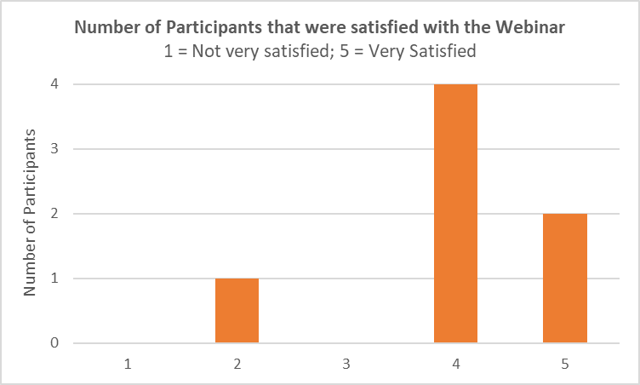
Several respondants also indicated that they found the topic of the webinar particularly useful since they were in the process of developing and implementing legislative decisions regarding living modified organisms in their country.
They also found that the ability to openly exhange views on the topic through the question-and-answer session with the resource persons was particularly relevant to them.
__________

A recording of the webinar is available at http://bch.cbd.int/onlineconferences/portal_detection/apwebinar.shtml

